RSI-Based Trading Signal Construction (Corrected)
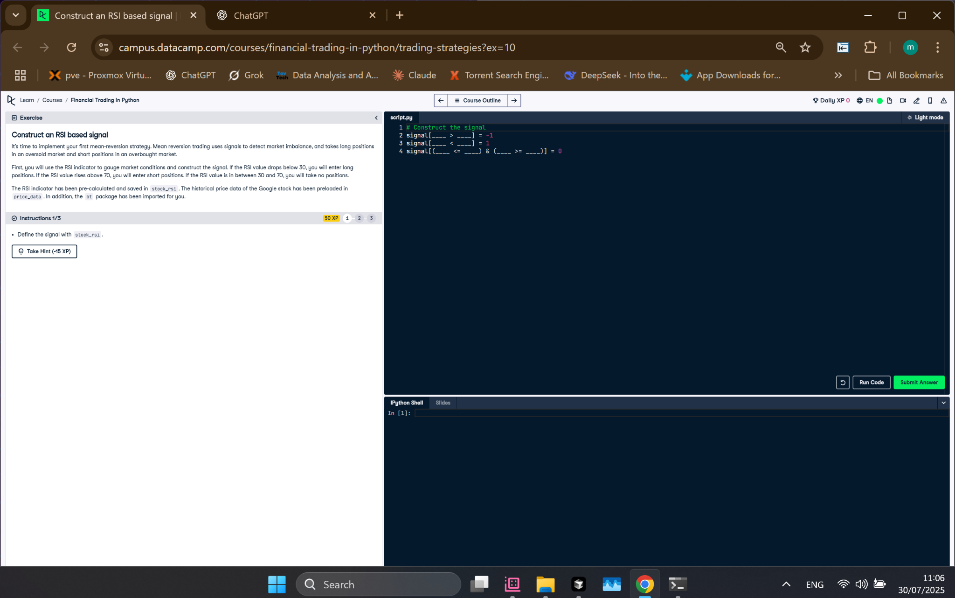
Figure: RSI Signal Construction Exercise Screenshot

Python Code
# Construct the signal
signal[stock_rsi > 70] = -1
signal[stock_rsi < 30] = 1
signal[(stock_rsi <= 70) & (stock_rsi >= 30)] = 0

Explanation
This code builds a trading signal using the RSI indicator. When RSI is over 70 (overbought), it gives a sell signal (-1). If RSI is under 30 (oversold), it gives a buy signal (1). If RSI is between 30 and 70, no action is taken (0).

